SIMATS ENGINEERING (SAVEETHA SCHOOL OF ENGINEERING)
Department of Computer Science and Engineering

ASSESSMENT TOOL 1 – C Code Output Prediction

Course Code: | CSA0305 | Course Title: |  | Data Structures
CO Assessed: | CO1 – Imitation (BL3, BL4) | Assessment: |  | Assessment Tool 1 – C Code Output Prediction
Weightage: | 35% of CIA | Total Marks: |  | 100
CO1 Statement: | Apply suitable data structures and ADTs for efficient problem solving by analyzing time and space complexity.
Student Name: | K.Pujitha |  | Reg. No.: | 192524149
Section / Batch: | 2nd year (AI&DS) |  | Date: | 08/07/2026
Code of Conduct
I K. Pujitha (192524149) certify that this submission is my original work and that I have adhered to the guidelines specified for this assessment. I understand that any violation of academic integrity rules will result in disciplinary action.
Signature of the Student: K. Pujitha
Instructions
- This test contains 20 Debugging & Optimisation Task questions. Total: 100 Marks (20*5).
- When a student answer using Scenario-Based, in evaluation the answer should be with following five requirements: Identify the problem type and constraints, Select appropriate data structure, Design the Solution, Optimization and efficiency, Clarity of representation.
- No negative marking. Unanswered questions carry zero marks.

Section / Topic | Focus | Q Nos | Marks
Linked data structure | Basic data structure | 1 - 2 | 20
Primitive and Non-Primitive Data Structure - Linear and Non-Linear Data Structure | Classifications of Linear data structure | 3 - 4 | 20
Search Data Structure | Linear Search and Binary Search | 5 -6 | 20
Recursion, Performance analysis | Recursion | 7 - 8 | 20
Array Data Structures | Implementations Using Array data structure | 9 - 10 | 20
GRAND TOTAL: |  | 100 Marks

1)

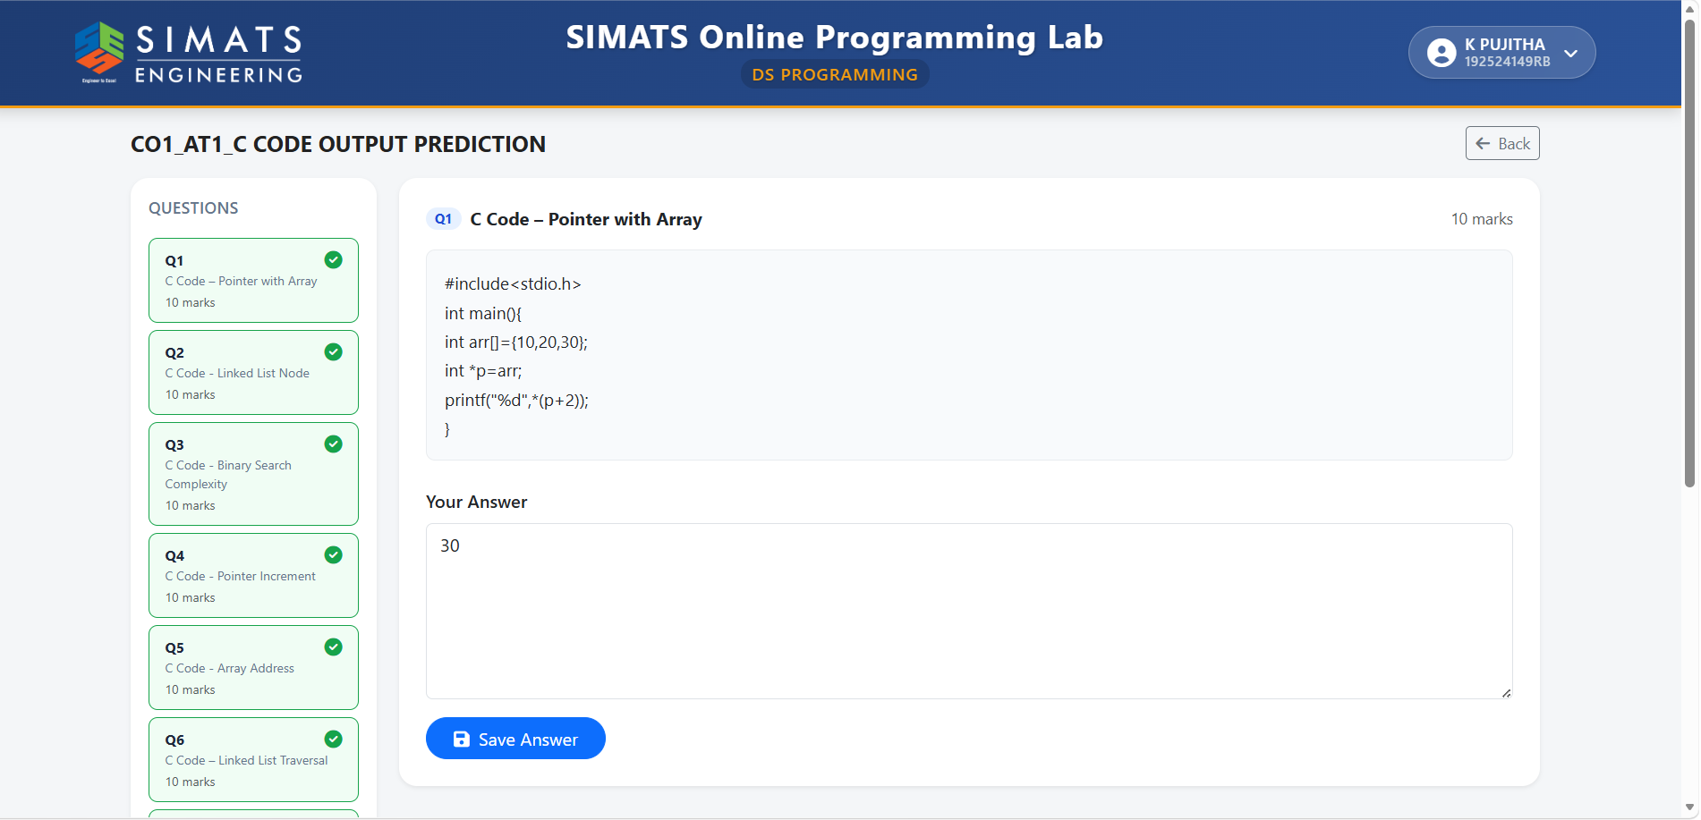

2)

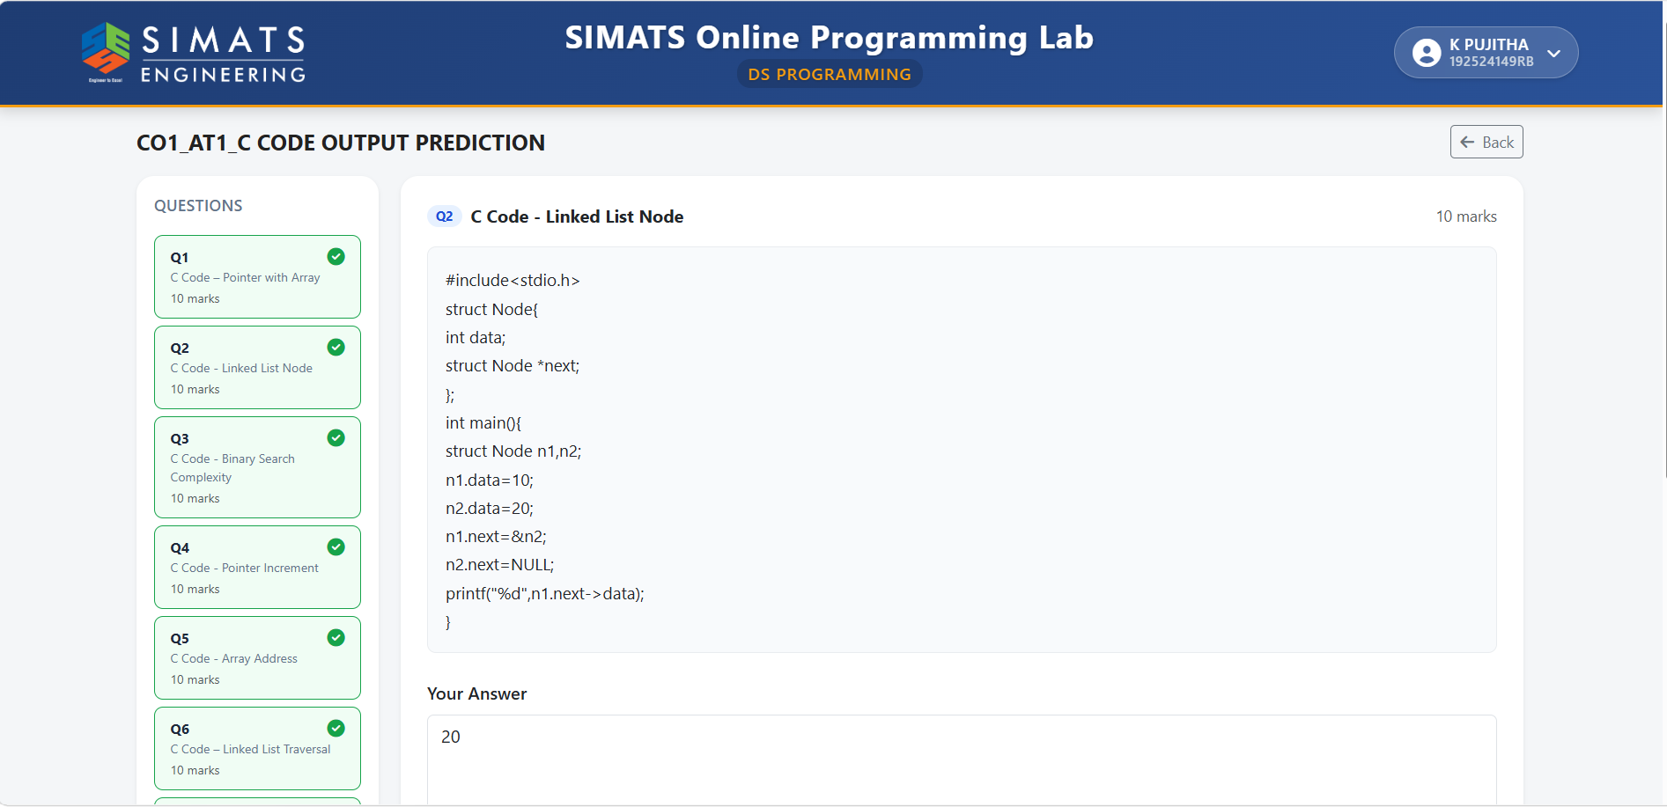

3)

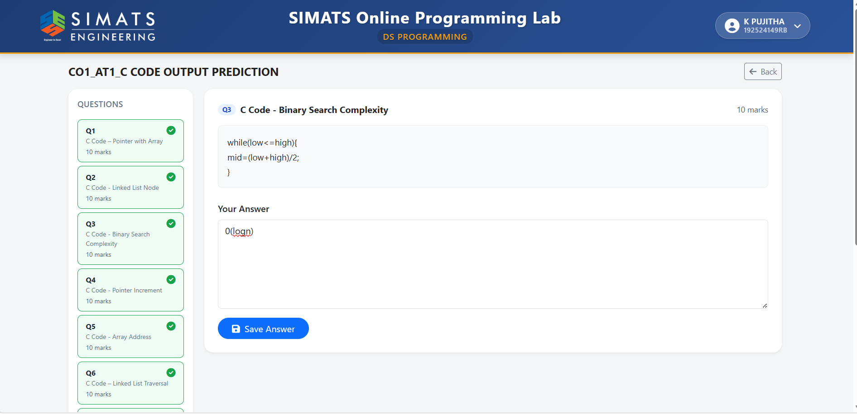

4)

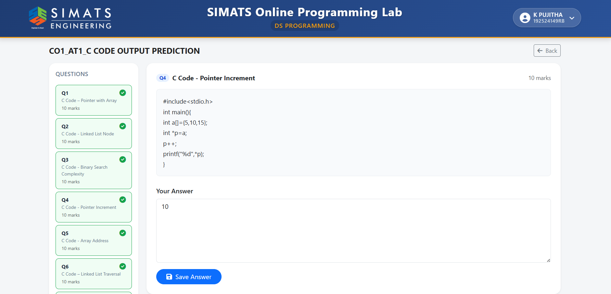

5)

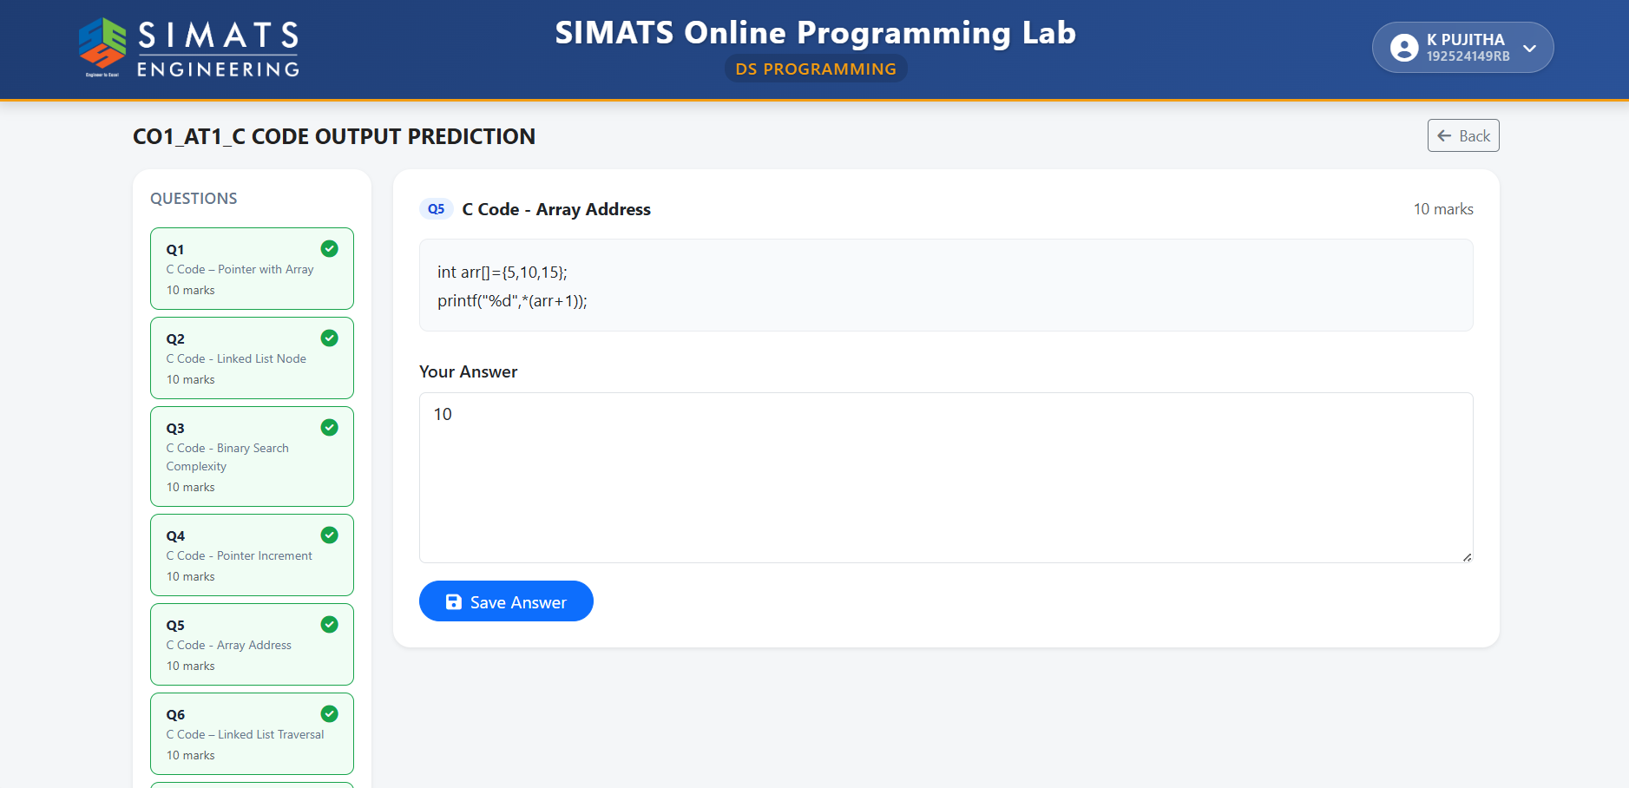

6)

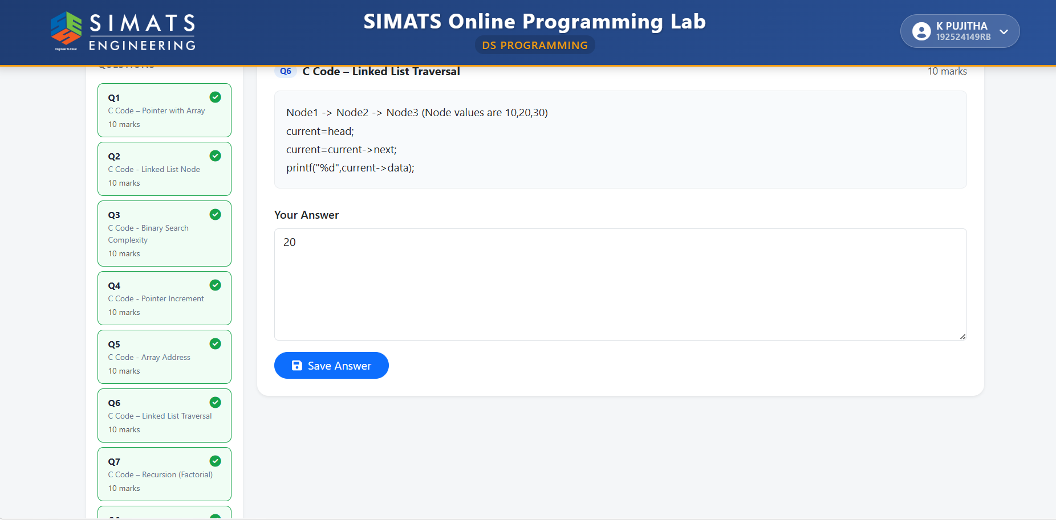

7)

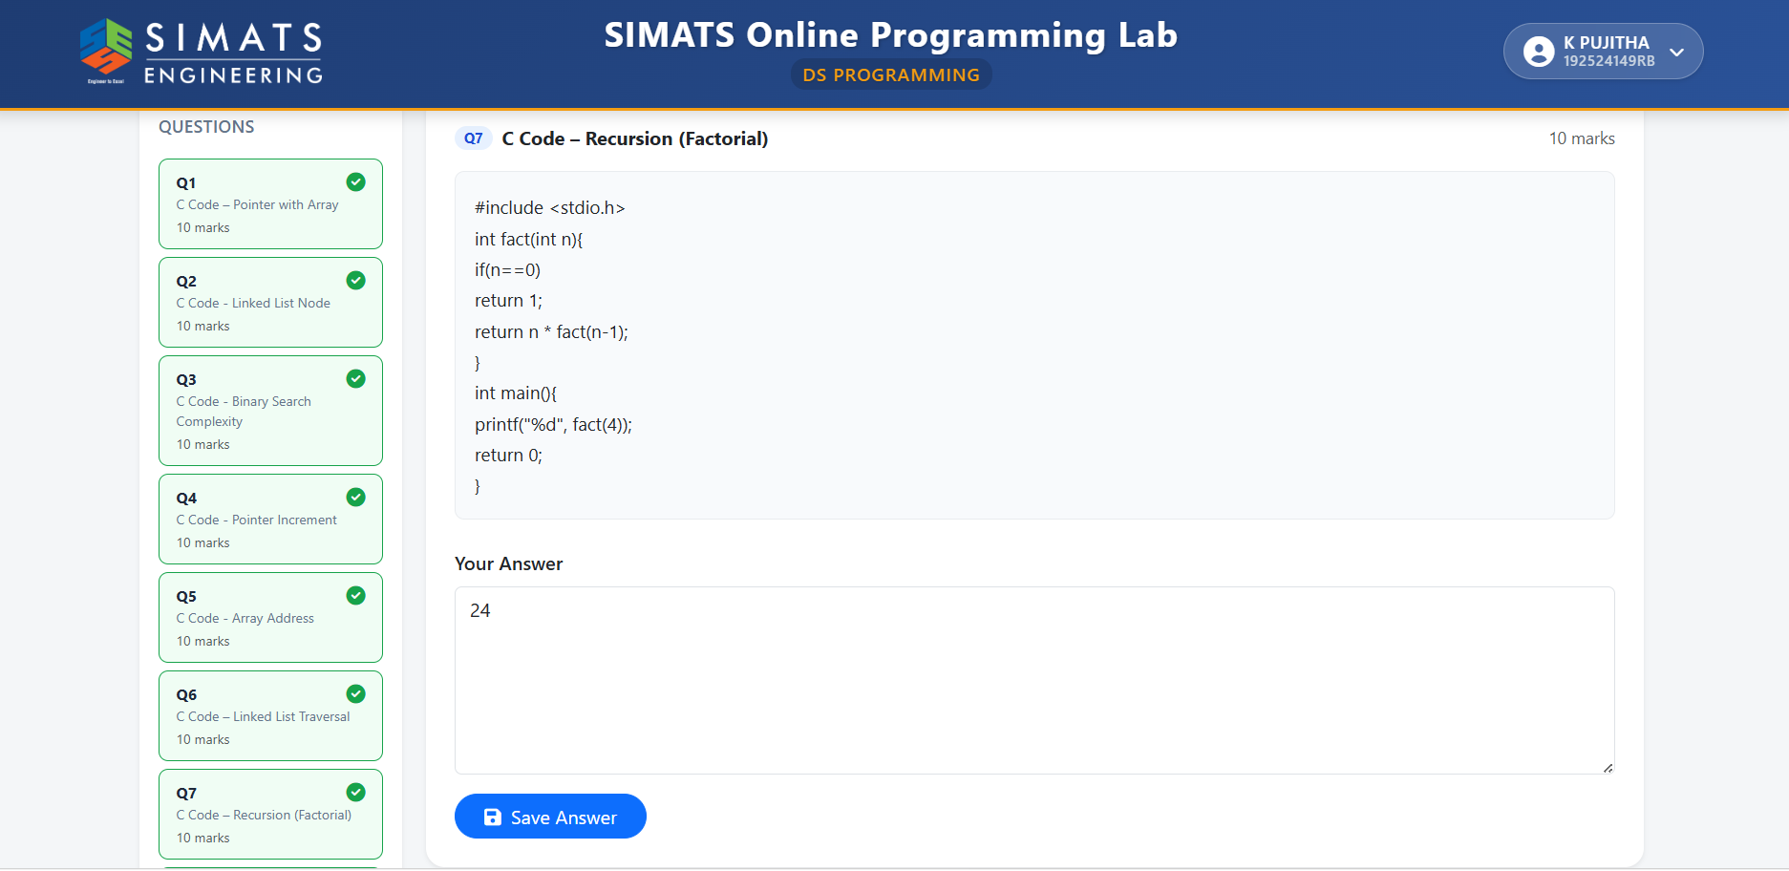

8)

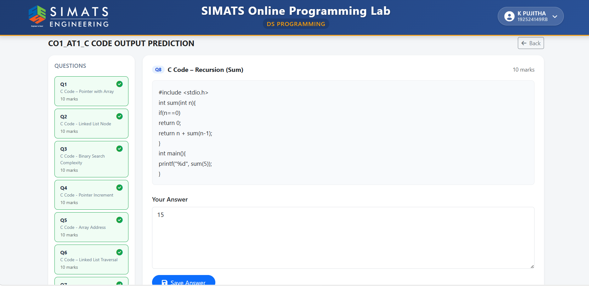

9)

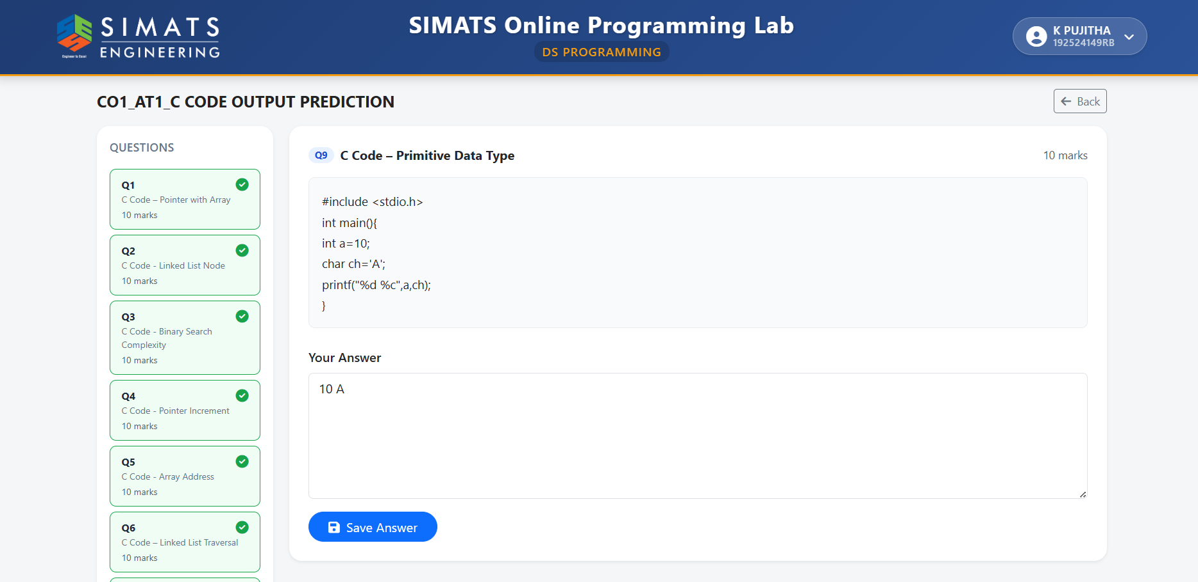

10)

